THE GREENHOUSE.

When it comes to his birthday, I would go to the shop and buy him a gift or a card for his special day; that was my intention always. But a few years ago, I went to a nursery and brought home three hyacinths flower pots. They were all smiling, showing off their beautiful colours of pink, white and purple, releasing a dizzy aroma that followed me to his office.
Because of personal reasons he has moved into a large room above his factory. With him is his friend Pluto, his beloved dog, a German shepherd. Pluto always sits or stays in a place where he could see his master. Seeing me coming with vibrant flower pots, Wally turned off the machine to come near me and asks, “What is going on here?”
- “Nothing, happy birthday to you”, I said.
- “Ah, thank you very much. They are beautiful, but where do we put these pots in this factory?”
- “I put one in your office, one in your room upstairs and one at the small dinner table, but in the factory, is that all right?”
- “Of course, it is all right dear. But here is not the right place for these pots”.
- “Doesn’t matter, where there is you and I, that place should have flowers blooming”.
He looked at me for a moment, ’OK let me think about it. Now you go upstairs make yourself comfortable, I am still busy with my work, be with you soon dear”.
Everything was in order upstairs; he had neatly prepared dinner by himself and there was no need for me messing things around. I always remember what he said to me before.
- “Please do not try to change me”. So, I’ve known what type of person he was and still is. I would not dare to think of trying to disturb him at all. Believe me, I am a very sensitive person, physically and mentality, so I am very cautious with his situation now. We are together to give comfort to each other to heal our broken hearts. For that reason alone, I would be very careful when to say or do something that could make him upset. Two days had gone by with a beautiful weekend for two of us- we really enjoyed the scent and the colours of the flowers.

A skin care class this morning for a group of women of multi-cultural background in a community hall is waiting for me to manage and I should be there at 10:00am sharp. Therefore, I left for work at 9:30; that would give me enough time to drive without worry of being late. When I came back in the afternoon, Wally was busy at the back of the factory. Nearby the truck was full of the logs he bought from the hardware store. Curiously I ask. ’What are you doing with these logs?”
- “I will make the greenhouse for the three hyacinths flower pots”.
- “What?”
- “You heard me, clearly didn’t you? I said I am going to make a greenhouse for your beautiful flowers”.
- “You shouldn’t have to; it would cost you a lot!”
- “Of course, it cost money dear”.
- “How much for all of this?”
- “I won’t tell you until I finish it. Now please do not interfere”.
My silence was best because in the past if I kept on nagging he would get mad at me. A sense of guilt rose inside me for bringing home the flowers and now he must work hard to gain a place, where it is suitable for them. But he seems very interested in doing it; always a pleasant smile on his face when he caught my eyes- southing my worry away.
- “You will see when I finish it”, he said, and added “I know you will love it, my dear”.

I kept smiling, watching him cut the wood, use screws to secure the metal foot for the log stand at the square marked to where the, little house full of love, would be situated. Four metal feet had to be fixed on the cement floor, so the logs could stand firmly on the ground floor; connecting them by four of the others; across the four-top post; then the shape of the roof had to be set on the top; an entrance opened at the front side. During that time, it was interesting for me to be involved.
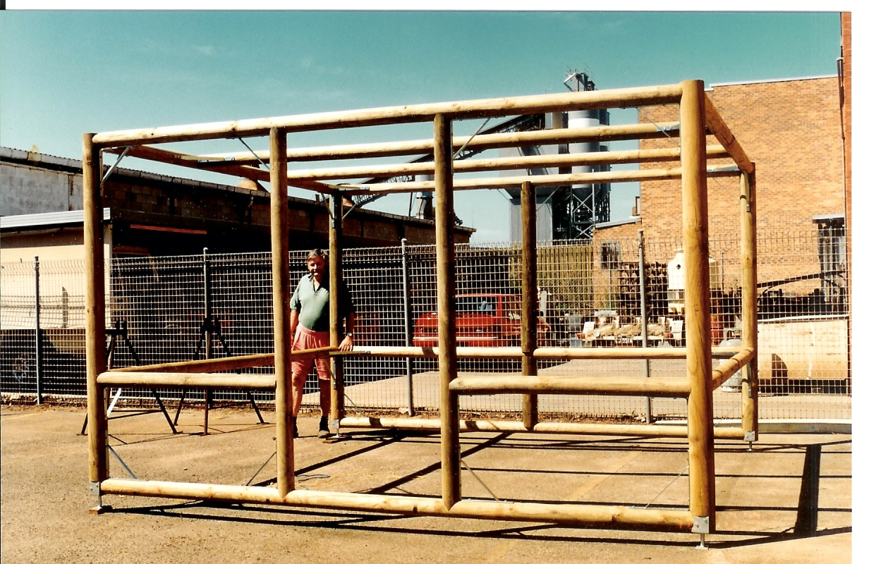
I often went to the nursery and purchased more flower pot plants; preparing to decorate the green house. He took the photo of the frame for the first time and then the second time when he finished it with the fly green completely covered.
- “Shelves will be adjusted outside and inside the shade”, he told me.
- “Shelves? Will cost more!”
- “Yes, that is how it should be dear, but you shouldn’t be worried, it will be ok”.

He himself, without any help from others, continues to make what he desires for me. The materials only, would’ve costed him thousands of dollars. I wouldn’t dare to count the labour work he put in the job either, never would’ve thought about it when I purchased the hyacinths flowers at all. I have no idea what made him build the greenhouse at the back of the factory like this. As a retiree with lots of time available he may need to move his physical body. People with hip replacements need to be careful with heavy work of lifting and I always bear in mind this problem he had to deal with. Very seldom he asks me to give him a hand or complained about the hip either; it’s amazing. Happily, he put his mind on the plan that he’s going to finish.

When I put the hyacinths and the other pot plants in, he stood by
pleasantly smiling.
- “What do you think?”. He asked.
- “This is what love is darling, thank you very much for your love for me; I am so thrilled and appreciate it. And now, could you please tell me how much did this wonderful idea cost you, all together?”
- “You must sit down, and can I ask you how much for three hyacinths pots?”
- “Not much, just only twenty-five dollars”.
- “You can calculate it for a hundred times without my labour work, dear”.
- “Oh Darling! that’s equal to my two months of commission
for working very hard darling! I would never dare ask you to spend that much amount, I’m sorry!”
- “Never mind my dear, remember that this is a gift for you; I’ve noticed that you love me truly and I build it with all my heart in return”.
- “My job is working harder now to put up with what your imagination will come up with next to show our love together, right?”
Cheerfully, excitedly, I laugh.
- “I agree with it! Now don’t you just stand there laughing? Keep working or you would waste your time for doing nothing”. He would boss me about.
- “Yes sir, I will be a very good worker, trust me!”
As I tendered the flowers and I thought what a man he is! At the beginning of our relationship we saw each other a few times a week; he didn’t look like a sentimental person at all. May it be the difference in cultural background that caused me to see that in him?
I always speak my mind honestly, but I still remember what he said to me once.
- “You wouldn’t know what love is!” when I said that I loved him!
I really don’t know why he did say that. It sounded unpleasant to me at that time. But I don’t mind. I thought; perhaps because of his personal crisis from his broken marriage, it still cuts him deep down? I said to myself: “Be patient dear, you are holding a broken heart and it is still bleeding heavily, it needs you to heal it properly; you have to look after it carefully; you have to dare the stress to enjoy his unconditioned love”. And I noticed that after the divorce he was getting better, becoming a nicer and more caring person than before. After time, he would tell me all the things that happened in his life; from when he was only a young boy to a young man and even all the relationships with women in the past. I was listening with my interested heart and respecting soul. He, the man from a war-torn country, Germany, in 1945 lost his father and brother in the World War II when he was only thirteen years of age; their remains had never been found.
I came here after the fall of Saigon with a heart that had broken into many pieces. My circumstances were so complicated, and I wouldn’t like to open the wound that had almost healed. We easily became very dear friends indeed.

He is a very good and nice person, always on time, neither late nor early, his punctuality caused me trouble sometimes; such as when we were going to a wedding. The invitation card clearly stated 6:30 in the evening. At six o’clock he was all dressed up, sat there and waited for me while I was still in front of the mirror dressing table trying to make myself beautiful for the night out. The reason for that is very simple because as a Vietnamese woman I had known that the wedding will start at 8:00 or 8:30pm for sure, but he could not believe it at all, until he hit the night of the particular couple who were to tie the knot. He said, “My dear, I tell you this; if you go to a westerner’s wedding, if it says 6:30 Pm it means 6:30 Pm sharp and if you came at 8:30 you will stay there and wash the dishes, clean the tables, mop the floor, ok!”
- “Yes, OK darling, but this is a Vietnamese wedding in the manner, so we must wait as naturally as the Vietnamese, you will get used to it without complaining. You see many people have also come late, nobody pays any attention at any body, they are busy like bees, talking, taking photos and enjoying each other and, I am very happy tonight with you, only that should count, nothing else. We may come home a bit late, but tomorrow is Sunday darling, we have nothing important to do”.
But I must say punctuation is the westerners’ good manner. I admit that I’ve learnt a lot from him about being on time with work, to get the result if time is limited, as driving everywhere was my job requirement, therefore time is very important for busy people.

Few months later our sensible Greenhouse wore a difference beautiful face with more colourful pots of flowers. Rose flower pots added a charming look for the little shade house. I put more vibrant colours outside, especially sun loving plants. With colourful flowering plants grouped together in one container, I displayed them around, the
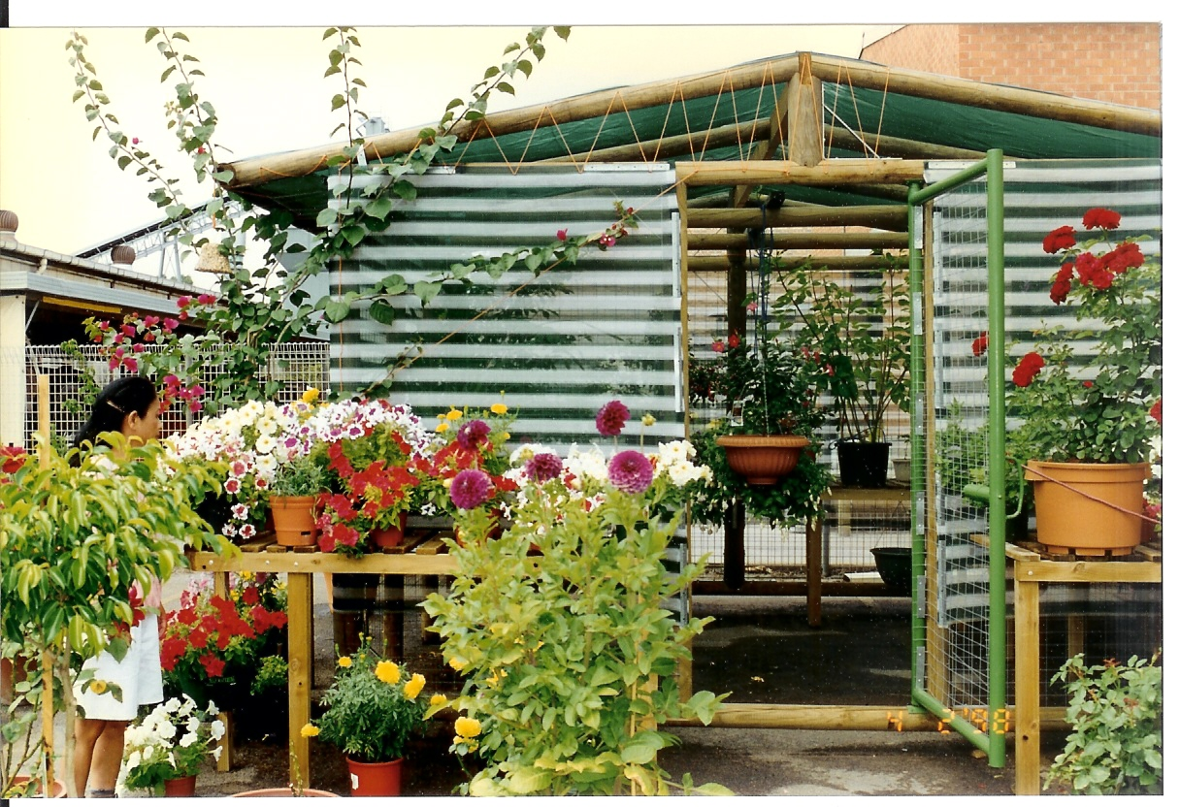
Marigold with yellow dress looked striking between them. The greenhouse looked attractive to us. I spent most of my spare time in the “garden” place. I fell in love with it, this is the garden I would never have dreamt of as my own. We put our love together in a real place now. It started with three hyacinths and grew into a greenhouse. How intelligent, marvellous, thoughtful he is. Don’t just judge that he was a man working with the hands all his life in the factory of his own. He has the heart of gold; his heart is soft and tender. He has shown me such loving care, I had ever felt in my life.

Anyway, I must face the fact that he must be looking for some where suitable for his retirement to settle down, again! That’s why, the machines in the factory were all sold in one lot. The Chevrolet, the truck and the car hoist were sold separately; the factory was sold at the end of 1999. He then bought a two-bed room house in the same suburb, in cash. We moved to a private house with a beautiful garden at the front. Most of the logs he used to build the green house had been dismantled and followed us to the new house. He used these logs to create the gate and named it “Brandenburg gate”. The frame was made for the

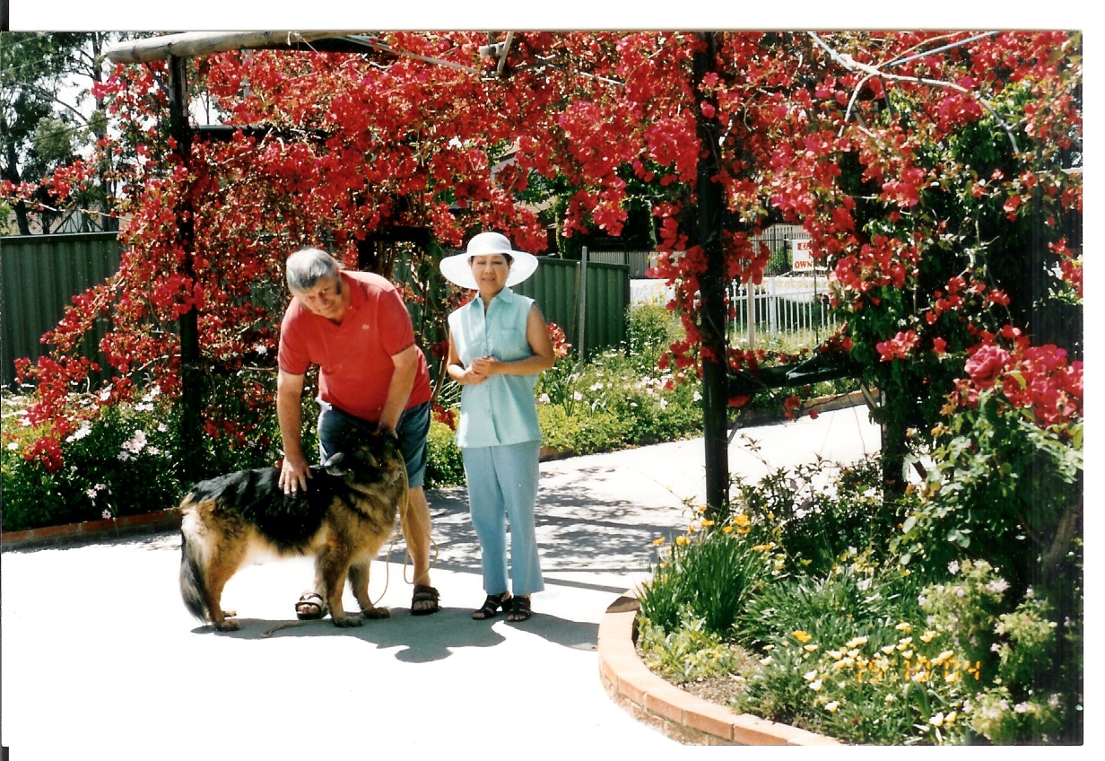
tropical shrub of bougainvillaea; which display sensational red flowers when they are blossoming. The flower plants were removed from their pots and laid in the soil to charm the garden. Now I keep some big pot plants along the fences around the house. The rest of the materials of the dismantled greenhouse weren’t wasted, he used them to construct the awning at the back, to connect the back door of the house to the garage, for us not to get wet when we take the car out for shopping or going around the country side for sightseeing. Along the awning we grew four grapes plants; those grapefruits gave me the pleasure of eating the fruit we grew by ourselves, very sweet! We had a lovely home at last.

There were birds, some of the beautiful birds came to the garden every day. More and more gathered because we fed them every day, in the morning early and in the afternoon at 4:30. Looking at the birds every day in the front of our home, I felt so good inside. But honestly, I’ve to say that I must work a lot more for cleaning the veranda every day.

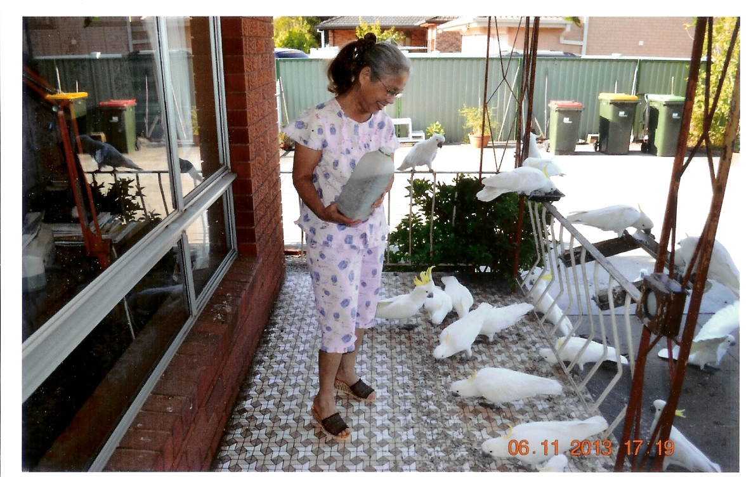

At that time, I was working as a consultant for Mary Kay Cosmetics Company and I was always busy with my work such as teaching skincare, selling the products, recruiting new members to have more women on my team, because I would like to share the benefits of knowing a good product to my friends and women around. I formed the skin care class for women in my community. Finding that the teaching skincare is helpful for women. Different community service staff invited me to help spread this initiative. I didn’t hesitate, I felt humble to accept it. So, I had two classes in a week, sometimes three. I recruited, built up a unit and became a Unit Sale Director in June 2001. I’ve really been very busy during the time of my directorship, but I made money and I enjoyed my work without complaint.

*****
I’m retired now, and every day is Sunday so, I find myself busy with reading, writing and gardening. I’m working in different ways for my health, I sometimes feel unwell, I need to rest, but I’m aware that doing nothing is no good for me. That is why I would keep myself busy with works. The relationship between us has been undamaged after twenty-six years and up to this present day, I think that could count a lot for something too. He is old, so am I. I would not know how long we will last but I always keep smiling till the end.

To here now, I would like to attach some photos of the Greenhouse and the two of us in the garden, hope you like them. Thank you for reading my story.

DTQT.
19/04/2018
